INTRODUCTION

Behavioral Design Pattern: State
In the development of this advanced Tetris game, the GameEngine class is required to manage several distinct operational phases: the main menu, active gameplay, a paused state, and the game over screen. Each phase demands completely different behavior in response to the same inputs. For example, pressing the arrow keys must navigate menu options in the menu phase, move the active piece during gameplay, and do nothing while paused. Without a structured solution, this conditional logic accumulates inside GameEngine as a growing chain of if/else or switch statements gated on an internal flag. Every new phase addition requires directly modifying GameEngine, making the class increasingly fragile and violating the Open/Closed Principle.
To address this, the State behavioral pattern was selected. The pattern encapsulates each game phase into its own dedicated class that fully owns the input handling, update logic, and rendering behavior for that phase. The GameEngine no longer contains any phase-specific logic; it holds a reference to the current GameState object and delegates all behavior to it. Transitions between phases are managed through a single changeState() call, which cleanly exits the current state and enters the new one.

Behavioral Design Pattern: Strategy

Design patterns are reusable solutions to common problems that appear in software development. They help developers write code that is clean, flexible, and easy to maintain. Among these patterns, the Strategy Pattern is one of the most widely used behavioral patterns.

The Strategy Pattern defines a family of algorithms, puts each algorithm into a separate class, and makes their objects interchangeable. This means that the client can choose which algorithm to use at runtime without changing the code that uses it. This approach follows the Open/Closed Principle, which states that a class should be open for extension but closed for modification.

In this report, we examine the Strategy Pattern through a real-world example: a Tetris game scoring system. The scoring system supports three different strategies Classic, Combo, and Timed and the active strategy can be changed dynamically during the game. This makes the Strategy Pattern an ideal choice for this use case.

Behavioral Design Pattern: Template
The Template Method is one of the behavioral design patterns defined by the Gang of Four (GoF). Its main idea is simple: define the skeleton of an algorithm in a base class (superclass) as a fixed method, but let subclasses decide how to implement specific steps. This keeps the general workflow in one single place, while allowing each subclass to define its own unique behavior. This pattern reduces code duplication, protects the structure of the algorithm, and supports expandability.
In the Tetris project analyzed in this report, the Template Method pattern is applied through the AbstractPiece class. In every tick of the game, updating the pieces (applying gravity, checking collisions, and locking) is the same for all pieces. However, what happens after locking changes from piece to piece. This difference is exactly the kind of problem that this design pattern is meant to solve.

Behavioral Design Pattern: Chain of Responsibility
In the architecture of this Advanced Tetris game, game events such as clearing lines, leveling up, or landing a piece trigger a multitude of secondary effects. For instance, a single "Line Cleared" event might need to calculate combo multipliers, check for portal interactions, and play specific audio files. If the GameEngine or a single event listener were to handle all these outcomes, it would quickly become a monolithic, tightly coupled class filled with complex conditional logic.
To prevent this and maintain a modular architecture, the Chain of Responsibility behavioral pattern was implemented to process game events. This pattern transforms the varied event responses into standalone objects called handlers. Instead of hardcoding the sequence of effects, an EffectManager catches the GameEvent and passes it to the head of a predefined handler chain. Each handler in the sequence evaluates the event, applies its specific logic (if applicable), and passes the event down the line. This completely decouples the event trigger from the specific effect implementations, allowing the game to dynamically process complex, cascading behaviors at runtime.

Behavioral Design Pattern: Iterator
In the development of this advanced Tetris game, two types of sequential traversal problems arise repeatedly: iterating over every Cell in a Grid (for rendering, collision detection, and board evaluation) and iterating over every row of a Matrix (for piece-shape manipulation). Without a structured solution, these traversals would be hardcoded directly into the GameEngine or scattered across multiple utility methods, each exposing the internal structure of Grid and Matrix to every consumer. Adding a new traversal order, such as column-first or diagonal traversal, would require modifying every call site.
To address this, the Iterator behavioral pattern was selected. The pattern encapsulates the traversal logic for each collection inside its own dedicated iterator class that implements a common GameIterator<T> interface. The GameEngine and all consumers never access Grid indices or Matrix dimensions directly; they interact exclusively through hasNext(), next(), and reset(). This completely decouples the traversal algorithm from the collection's internal representation, keeping both open to independent evolution.
- Behavioral Design Pattern: Observer
In the architecture of this Advanced Tetris game, significant in-game occurrences—such as clearing a line, leveling up, or a piece landing—must trigger reactions across multiple independent subsystems simultaneously: the ScoreManager must recalculate points, the AudioSystem must play the correct sound effect, and the EffectManager must initiate the corresponding environmental animation. A straightforward implementation would require the GameEngine to hold direct, concrete references to each of these subsystems and call their update methods explicitly on every event. This creates tight coupling: the GameEngine becomes directly aware of every consumer, meaning that adding or removing any reactive subsystem forces changes to the GameEngine source code, violating the Open/Closed Principle.
To prevent this, the Observer behavioral pattern was implemented to establish a publish-subscribe mechanism between the GameEngine and its dependent subsystems. The GameEngine, acting as the publisher (subject), maintains a registry of subscribed GameEventListener instances and broadcasts a GameEvent object upon detecting a significant occurrence, without any knowledge of the concrete types or internal logic of its listeners. Each listener handles the notification in its own encapsulated manner. This cleanly decouples the event trigger from the systems that react to it, making the architecture both extensible and maintainable.

METHODOLOGY

Behavioral Design Pattern: State
Methodology and Architectural Relationships The State pattern is structured around a central GameState interface that defines five behavioral contracts: onEnter(engine), onExit(engine), handleInput(engine, key), update(engine), and render(engine). Each concrete state class implements this interface and handles only the responsibilities of its own phase, with no awareness of other states.
Four concrete states are present in the architecture. MenuState displays the main menu and transitions to PlayingState upon receiving the ENTER key. PlayingState is the active game phase; it delegates all keyboard input through the CommandHistory invoker and runs the core game loop tick. PausedState suppresses the update() call entirely, freezing the game, and transitions back to PlayingState on P or to GameOverState on ESC. GameOverState displays the final score and level, prompts the player to enter a UUID for the scoreboard, and returns to MenuState on ENTER.
Transitions are managed exclusively through GameEngine.changeState(GameState newState). This method calls currentState.onExit(engine) on the outgoing state before replacing the reference, and then calls newState.onEnter(engine) on the incoming state. This guarantees that every state performs its own setup and cleanup without leaking side effects into other states.
The state transition flow is illustrated below:
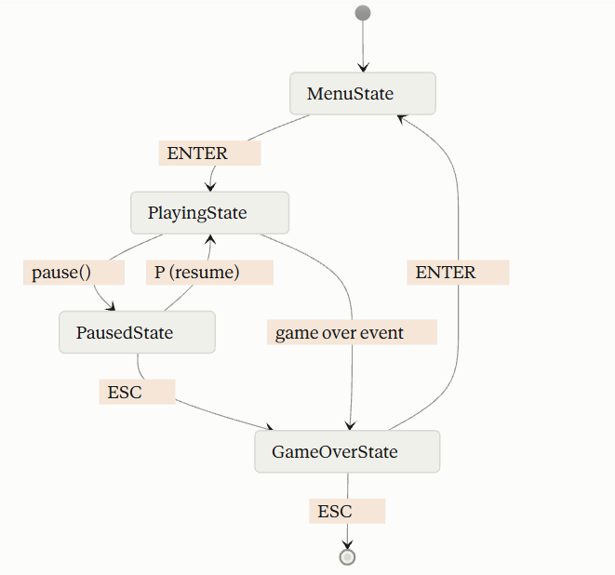
The UML class diagram below shows the structural relationships between GameEngine, the GameState interface, and the four concrete state classes:
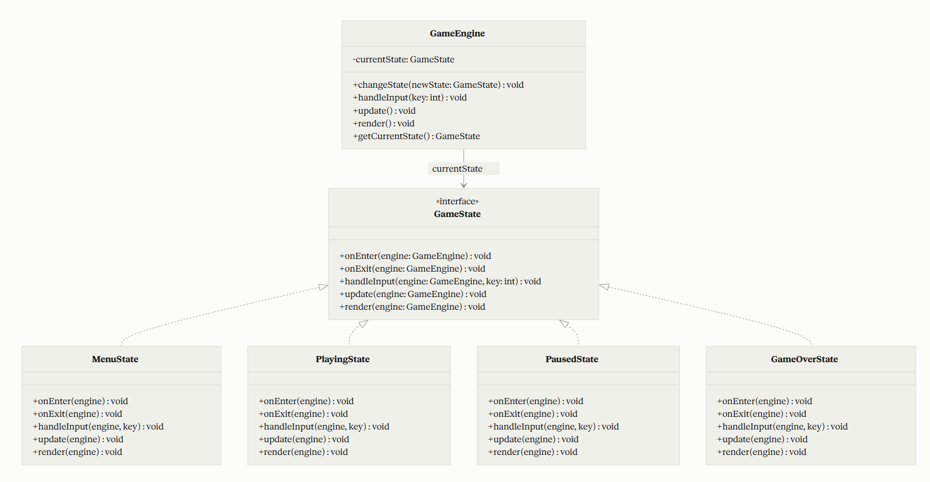

Behavioral Design Pattern: Strategy

To implement the Strategy Pattern in the scoring system, the following steps were taken:
First, a common interface was defined so that all scoring strategies could share the same method signatures. Then, each scoring algorithm was implemented as a separate class that implements this interface. Finally, a context class (ScoreManager) was created to hold a reference to the current strategy and delegate scoring calculations to it.
The implementation consists of four main components: the ScoringStrategy interface, three concrete strategy classes, and the ScoreManager context class. The diagram below shows the general structure of the pattern.

Component | Description
ScoringStrategy | The interface that defines the contract for all scoring strategies. It declares the calculateScore() and getStrategyName() methods.
ClassicScoringStrategy | Implements the traditional Tetris scoring formula. Points are multiplied by the current level, and a small combo bonus is added.
ComboScoringStrategy | Rewards consecutive line clears with increasing multipliers, ranging from 1.0x up to 3.0x.
TimedScoringStrategy | Adds a time-based bonus to the base score. The faster the player clears lines, the higher the bonus.
ScoreManager | The context class that holds the current strategy and delegates score calculation to it. The strategy can be swapped at any time using setStrategy().
To illustrate the structure of the Strategy Pattern, a UML class diagram below was created. The diagram includes five elements: the ScoringStrategy interface, three concrete implementations ClassicScoringStrategy, ComboScoringStrategy, and TimedScoringStrategy and the ScoreManager context class. The concrete classes implement the interface, shown with dashed arrows and hollow triangle arrowheads. ScoreManager holds a reference to ScoringStrategy and delegates score calculation to it at runtime, which means the active strategy can be replaced without changing the context class.

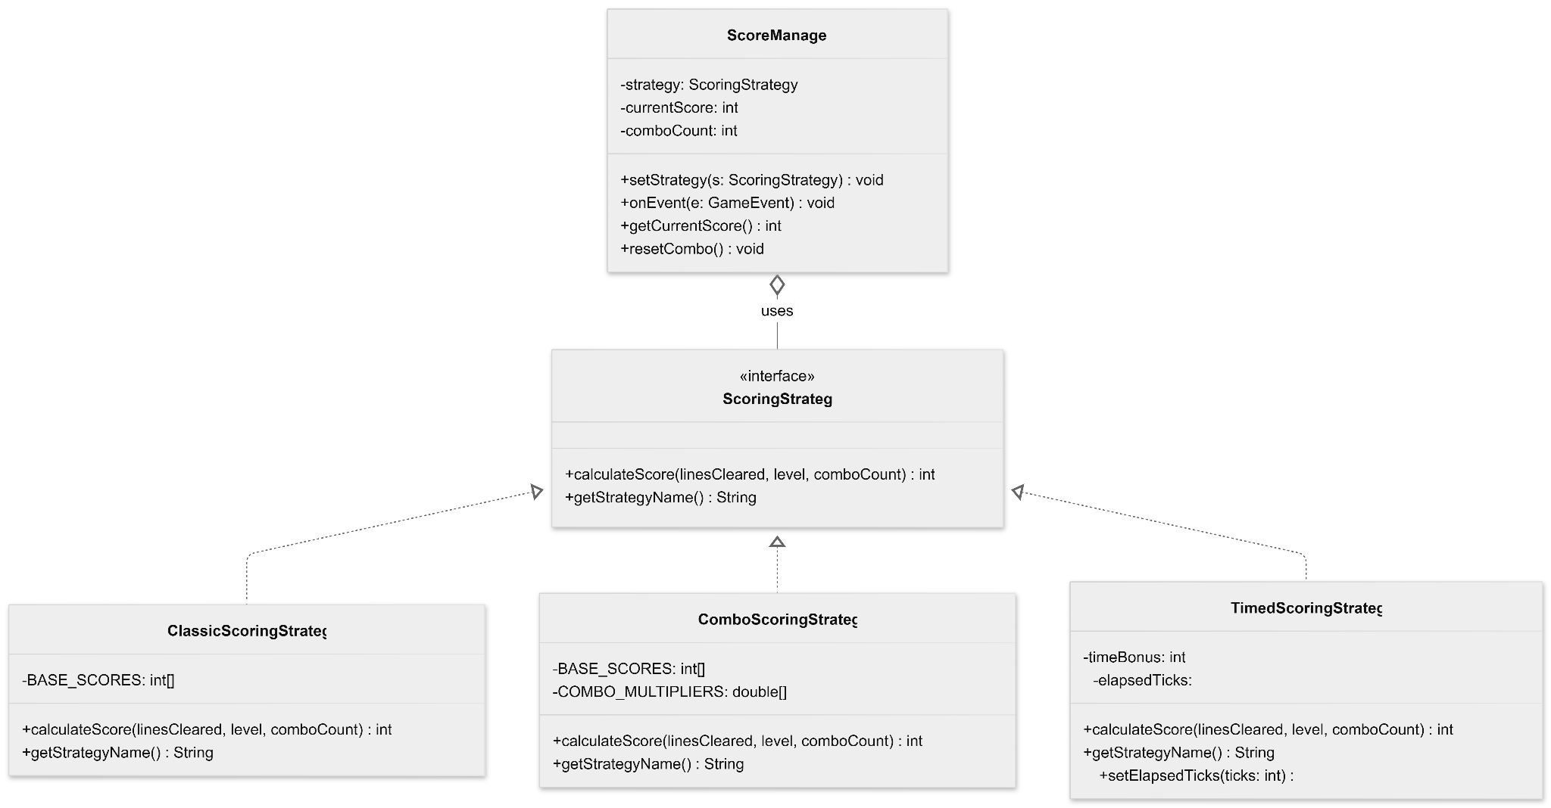

Behavioral Design Pattern: Template

When analyzing the implementation in the project, four files were taken as the main focus: AbstractPiece.java, IPiece.java, TPiece.java, and OPiece.java. The analysis covers how the class hierarchy is built, what steps are included in the locked template method using the final keyword, which methods are opened to subclasses as abstract or protected, and how each subclass fills these hooks. Additionally, the testTemplateMethod() inside Main.java was reviewed to confirm the test flow.
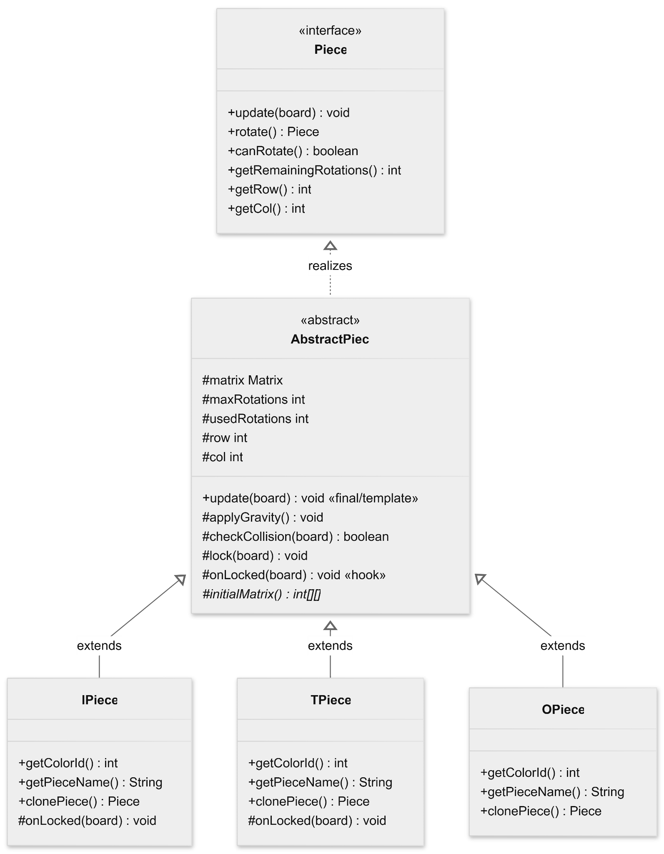
The UML class diagram clearly shows the hierarchical structure of the Template Method pattern in the project. At the top, the Piece interface defines the basic contracts, while the AbstractPiece abstract class sits below it to lock the algorithm skeleton as a final/template method. AbstractPiece holds the shared variables and defines the onLocked(board) method as a hook for subclasses to customize. Looking at the concrete classes that extend (extends) this abstract class, IPiece and TPiece override this hook method to run their own special logic, whereas OPiece does not override it at all, directly inheriting the empty default implementation from the superclass because it does not need any special behavior.

Behavioral Design Pattern: Chain of Responsibility
The methodology for integrating the Chain of Responsibility pattern centers on creating a sequential processing pipeline to evaluate and act upon GameEvent objects triggered during gameplay. This approach transitions the system from a centralized, monolithic event-handling structure to a decentralized, modular one. The implementation is divided into three core architectural components:
- The Abstract Handler (EffectHandler): This abstract base class establishes the structural foundation of the chain. It maintains a protected reference to the subsequent handler (nextHandler) and implements the passToNext() method, ensuring that requests can seamlessly traverse the sequence. It also defines the abstract handle() method, forcing all subclasses to adhere to a strict contract.
- The Concrete Handlers: These are specialized, single-responsibility classes (GravityEffectHandler, PortalEffectHandler, ComboEffectHandler, and AudioEffectHandler). Each handler evaluates the incoming GameEvent (such as LINE_CLEARED or LEVEL_UP). If the event falls within its domain, the handler executes its specific logic (like calculating combos or playing audio) and independently passes the event down the line to ensure cascading effects are not interrupted.
- The Client / Orchestrator (EffectManager): Acting as the bridge between the game's Observer mechanism and the Chain of Responsibility, this class manages the pipeline. It listens for broadcasted events from the GameEngine, constructs the specific handler sequence (Gravity → Portal → Combo → Audio) upon initialization, and routes incoming events to the head of the chain for processing.
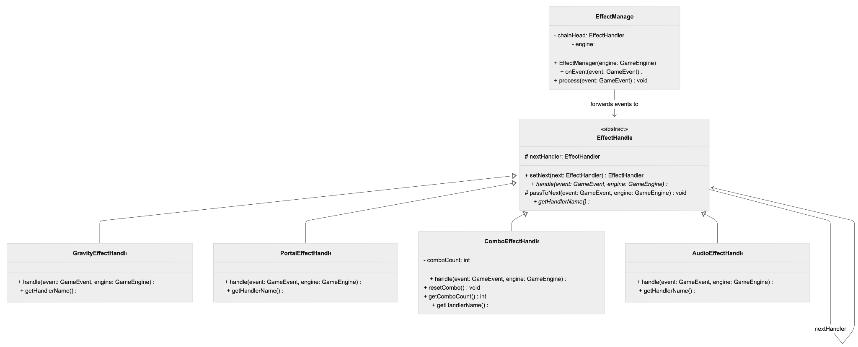

Behavioral Design Pattern: Iterator
The Iterator pattern is structured around a single generic interface, GameIterator<T>, that defines three behavioral contracts: hasNext() returns a boolean indicating whether elements remain; next() advances the cursor and returns the next element of type T; and reset() rewinds the cursor to the beginning, enabling repeated traversal of the same collection without constructing a new iterator.
Two concrete iterator classes implement this interface. CellIterator implements GameIterator<Cell>, traversing a Grid in left-to-right, top-to-bottom (row-major) order. It maintains two integer cursor fields, row and col, and advances col on each next() call, wrapping to the next row when the column boundary is reached. MatrixRowIterator implements GameIterator<int[]>, traversing a Matrix one complete row at a time. Each call to next() copies the current row into a new int[] array and advances the currentRow cursor.
The UML class diagram below shows the structural relationships between the GameIterator<T> interface, the two concrete iterator classes, and the Grid and Matrix collections they traverse:
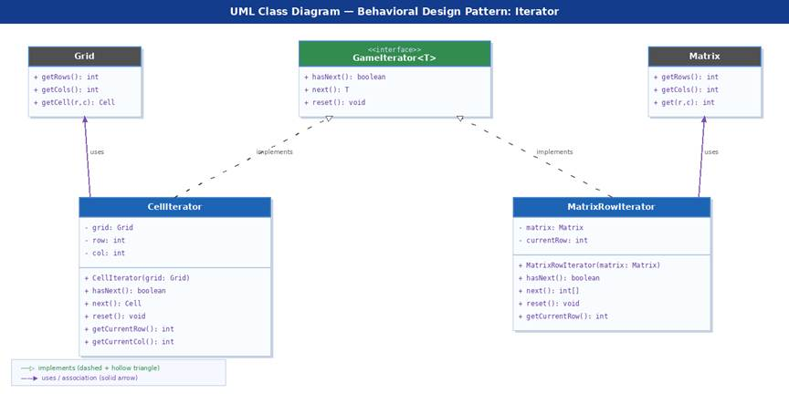
Null-safety is enforced in both constructors via an IllegalArgumentException guard, ensuring that iterators cannot be created over null collections. Boundary violations in next() are reported through a RuntimeException, consistent with the fail-fast contract common in Java iterators. Neither concrete class holds any reference to the GameEngine; both are lightweight, stateless-except-for-cursor objects with no circular ownership.
The sequence diagram below illustrates the interaction between a client (the game loop), CellIterator, Grid, and Cell during a complete traversal cycle:
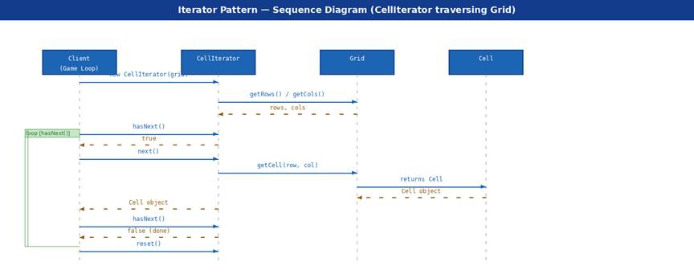
- Behavioral Design Pattern: Observer
The Observer pattern is structured around three core components: the Subject (GameEventPublisher), the Observer interface (GameEventListener), and the Event Data Object (GameEvent).
GameEvent is an immutable data-transfer object that encapsulates all information about a single in-game occurrence. It carries an event type identifier—such as LINE_CLEARED, LEVEL_UP, PIECE_LANDED, or PORTAL_ACTIVATED—and an integer payload providing contextual data, for example the number of lines cleared simultaneously. By packaging event data into a dedicated object, observers receive a complete, self-describing notification without querying the game state independently.
GameEventListener is a pure abstract interface that defines the contract all concrete observers must fulfill. It declares a single abstract method, onGameEvent(GameEvent event), which GameEventPublisher invokes on each registered listener. Any subsystem that wishes to respond to game events must implement this interface, guaranteeing a uniform notification protocol across the architecture.
GameEventPublisher is the concrete subject. It maintains a registry of active GameEventListener instances and exposes registerListener() and removeListener() methods for managing subscriptions. At appropriate points in the game loop, it constructs a GameEvent and calls notifyListeners(), which iterates the registry and dispatches the event to each subscriber. Concrete observers—ScoreManager, EffectManager, and AudioSystem—register themselves during system initialization and implement GameEventListener with domain-specific handling logic.
The UML class diagram below illustrates the full structural relationship between all participants:
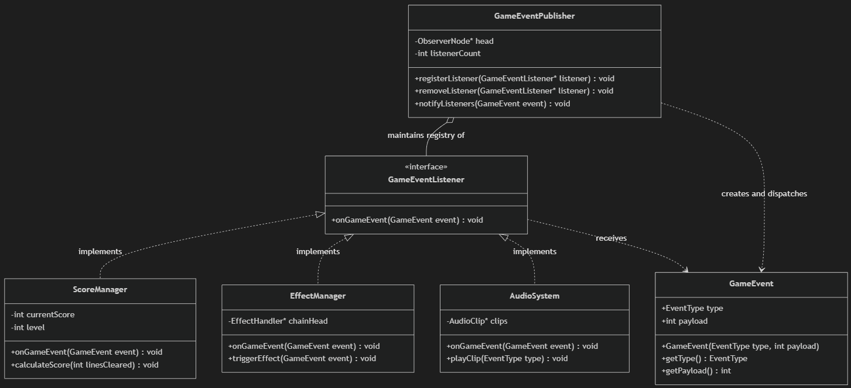

IMPLEMENTATION DETAILS

Behavioral Design Pattern: State
GameState is defined as a Java interface. All five methods receive the GameEngine instance as a parameter, giving each state full access to the engine's public API—board access, score retrieval, gravity control, and state transition—without any state class holding a direct reference to the engine as a field. This keeps state objects lightweight and free of circular ownership.
GameEngine was extended to hold a GameState currentState field alongside the existing CommandHistory and GameEventPublisher infrastructure introduced for the Command and Observer patterns respectively. The changeState() method is the sole transition point in the entire system; no concrete state class calls another state's methods directly, and no state class instantiates another state unprompted. All transition decisions are local to the state that initiates them, passed back through changeState() on the engine reference.
A notable implementation detail concerns PlayingState. Rather than duplicating input routing logic, PlayingState.handleInput() constructs the appropriate Command object (from the Command pattern) and pushes it to CommandHistory via the engine reference. This means the State and Command patterns are directly composed: the state determines which command to create, and the command history determines how it is executed and whether it can be undone.
PausedState deliberately provides an empty body for update(). This is the mechanism by which the game loop is frozen — the engine continues to call update() each tick, but the current state simply does not act on it. No additional flags or boolean fields are needed inside GameEngine to track whether the game is paused; the state object itself encodes that information structurally.
Since the no-STL constraint applies throughout the project, no state object uses any built-in Java collection. GameOverState stores the final score and level as primitive int fields copied from the engine on onEnter(), requiring no dynamic data structures.

Behavioral Design Pattern: Strategy

The ScoringStrategy interface is the foundation of the pattern. It defines two methods that every concrete strategy must implement:
public interface ScoringStrategy {
int calculateScore(int linesCleared, int level, int comboCount);
String getStrategyName();
}

By programming to this interface rather than to specific classes, the ScoreManager does not need to know anything about the internal details of the strategies. This is the key benefit of the Strategy Pattern.
The ClassicScoringStrategy uses the traditional Tetris scoring table. The base score depends on the number of lines cleared: 1 line gives 100 points, 2 lines give 300, 3 lines give 500, and 4 lines (a Tetris) give 800. All values are multiplied by the current level. An additional combo bonus of 50 points per combo count is also added.
The formula is: score = BASE_SCORES[linesCleared] * level + comboCount * 50 * level.
The ComboScoringStrategy rewards players who clear lines consecutively. It uses a multiplier array that increases with each consecutive clear. The multipliers are 1.0x, 1.5x, 2.0x, 2.5x, and 3.0x. After reaching the maximum multiplier, it stays at 3.0x for all further combos.
The formula is: score = (int)(BASE_SCORES[linesCleared] * level * COMBO_MULTIPLIERS[comboCount]).
The TimedScoringStrategy adds a time bonus to encourage fast play. The bonus decreases as more ticks pass. It is calculated as follows: the maximum time bonus is set when the strategy is created, and for each elapsed tick, the bonus shrinks. This pushes the player to clear lines as quickly as possible.
The formula is: score = base + Math.max(0, (timeBonus - elapsedTicks) * 2) + comboCount * 30 * level.
The ScoreManager class acts as the context in the Strategy Pattern. It stores a reference to the current ScoringStrategy and calls its calculateScore() method whenever a LINE_CLEARED event occurs. The strategy can be changed at any time by calling setStrategy(), which prints a log message showing the transition.
The ScoreManager also implements the GameEventListener interface, which means it reacts to game events such as LEVEL_UP, GAME_OVER, and COMBO_ACHIEVED. This integration shows how the Strategy Pattern works well alongside the Observer Pattern.

Behavioral Design Pattern: Template
The update(Board board) method in the AbstractPiece class is defined with the final keyword. This prevents subclasses from changing (overriding) the method and guarantees that the skeleton of the algorithm cannot be modified. The method consists of three main steps:
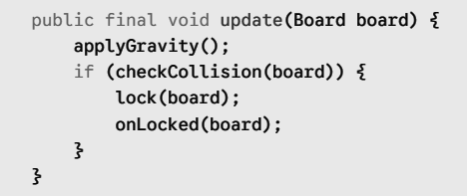
First, applyGravity() is called to move the piece down by one row. Next, checkCollision(board) checks if the piece hits anything on the board. If there is a collision, lock(board) locks the piece onto the board, and finally, onLocked(board) is called.
All four steps are defined inside AbstractPiece. However, the onLocked(board) method is intentionally left empty as a protected hook. Subclasses can override this hook to add special behavior after the piece is locked. On the other hand, applyGravity(), checkCollision(), and lock() have default implementations in the superclass, which can be overridden if needed.
- IPiece: It overrides the onLocked() hook to trigger the line-clearing mechanism by calling board.clearLines(). Since the I-piece takes up four horizontal cells, checking and clearing full lines after it locks makes a lot of sense.
- TPiece: It uses the onLocked() hook to detect a "T-Spin". After locking, it checks the four corner cells around the center point of the piece. If three or four of them are full, it logs a T-Spin message to the console. This is a specific game mechanic that belongs only to the T-piece.
- OPiece: It does not override the onLocked() hook at all. Therefore, the empty default implementation from the superclass runs. Since the O-piece does not need any special behavior when locked, this is a perfectly valid design choice. Additionally, OPiece limits its maximum rotation count to 1 by using the super(1) call; because a square is symmetrical, a single rotation state is enough.
- initialMatrix(): This method is also part of the pattern. It is defined as abstract, meaning each subclass must define its own starting matrix. This leaves the shapes of the pieces completely to the subclasses while managing the coordination logic centrally in the superclass.

Behavioral Design Pattern: Chain of Responsibility
EffectHandler is defined as an abstract Java base class. The core handle() and passToNext() methods receive both the GameEvent and the GameEngine instance as parameters. This grants each concrete handler full access to the engine's public API—such as gravity control and event dispatching—without any handler class holding a direct reference to the engine as a persistent field. This keeps the handler objects lightweight, stateless (where appropriate), and completely free of circular ownership.
EffectManager was introduced to serve as the structural client for the chain, hooking directly into the existing GameEventPublisher infrastructure introduced for the Observer pattern. The manager registers itself as a listener to the engine. When an event is broadcast, the process() method is the sole entry point into the chain; it pushes the event strictly to chainHead. No concrete handler instantiates or calls another handler's methods directly from the outside. All traversal decisions are local to the handler processing the event, passed forward through the protected passToNext()invocation.
A notable implementation detail concerns ComboEffectHandler and its integration with the Observer pattern. Rather than calculating and hardcoding score updates directly, when ComboEffectHandler.handle() detects that the combo threshold is reached, it constructs a brand-new GameEvent (of type COMBO_ACHIEVED) and publishes it back to the system via engine.notifyListeners(). This means the Chain and Observer patterns are cyclically composed: the Observer feeds events into the Chain, and the Chain can dynamically evaluate game state to emit new derivative events back into the central event bus.
PortalEffectHandler and GravityEffectHandler dynamically filter execution by evaluating the event.getType()payload. This is the mechanism by which irrelevant operations are bypassed—the engine dispatches all events blindly, but the current handler simply acts as an empty passthrough for event types it does not own. No additional boolean flags or routing logic are needed inside GameEngine to determine which effects trigger when; the handler objects themselves encode that filtering structurally.
Since the no-STL constraint applies throughout the project, the handler sequence does not use any built-in Java collections (like ArrayList or LinkedList) to store the chain. Instead, the chain is constructed as a custom singly-linked structure via the protected EffectHandler nextHandler reference. The setNext() method is implemented with a fluent interface, returning the appended handler to allow sequential memory allocation (gravityHandler.setNext(portalHandler).setNext(comboHandler)) strictly through object pointers, requiring no dynamic data structures.

Behavioral Design Pattern: Iterator
The GameIterator<T> interface is defined as a generic Java interface. The type parameter T is resolved to the concrete element type at each usage site: Cell for grid traversal and int[] for matrix row traversal. This single interface is the sole contract through which all consumers interact with any iterator in the system.
CellIterator is the primary game iterator. It receives a Grid reference in its constructor and stores it as a final field to guarantee that the iterator always references the same grid throughout its lifetime. The cursor state is encoded in two int fields, row and col. The hasNext() check is kept deliberately simple:
public boolean hasNext() {
return row < grid.getRows();
}
This single comparison is sufficient because col always resets to zero when row advances, meaning row >= grid.getRows() precisely captures the exhausted state regardless of the current column value. The next() method calls grid.getCell(row, col), increments col, and wraps to the next row when the column boundary is reached. Two read-only accessors, getCurrentRow() and getCurrentCol(), expose the cursor position for diagnostic purposes without breaking encapsulation.
MatrixRowIterator follows the same cursor pattern but operates on a Matrix and yields entire rows. Because the no-STL constraint applies throughout the project, the returned int[] is a newly allocated plain Java array, not an ArrayList. The row is populated in a single loop over matrix.getCols(), and currentRow is advanced afterward. A notable detail is that this design returns a defensive copy of the row data: the caller receives an independent array, so any mutation does not affect the underlying matrix, preventing subtle aliasing bugs.
Since the no-STL constraint applies throughout the project, neither iterator class uses ArrayList, LinkedList, or any other built-in Java collection to store or manage cursor state. All state is encoded in primitive int fields, keeping the iterator objects minimal in both memory footprint and complexity.
- Behavioral Design Pattern: Observer
Since the no-STL constraint applies throughout the project, GameEventPublisher cannot maintain its registry of listener pointers using any built-in container such as std::vector, std::list, ArrayList, or LinkedList. Instead, the registry is implemented as a manually managed singly-linked list constructed from raw dynamic memory allocation.
A private inner structure, ObserverNode, is defined within GameEventPublisher. Each node holds a raw pointer to a GameEventListener instance and a pointer to the next ObserverNode in the chain. The publisher maintains a head pointer initialized to nullptr and an integer listenerCount. Registration allocates a new ObserverNode on the heap and prepends it to the list in O(1) time. Removal traverses the list to locate the target node, re-links the predecessor to the successor, and explicitly deallocates the removed node to prevent memory leaks. The publisher destructor iterates the entire list and deallocates each ObserverNode, ensuring no memory is leaked when the publisher is destroyed. Crucially, the publisher does not take ownership of the listener objects themselves—it owns only the ObserverNode wrappers—so listener instances are not deleted by the publisher, correctly respecting their independent lifecycles.
Notification is performed by the notifyListeners(GameEvent event) method, which performs a linear traversal of the linked list and invokes onGameEvent() on each registered listener. The traversal requires no knowledge of the concrete observer type, operating exclusively through the GameEventListener interface pointer and relying on virtual dispatch to resolve the correct overridden implementation at runtime.
Since no STL iterator or range-based loop is used, the traversal is a manual while-loop over raw ObserverNode pointers, consistent with the custom iterator and grid-traversal strategies applied elsewhere in the project.

RESULTS AND CONCLUSION

Behavioral Design Pattern: State
The State pattern successfully eliminates all phase-conditional branching from GameEngine. The class no longer contains any if (phase == PLAYING) or equivalent logic; its handleInput(), update(), and render() methods each consist of a single delegating call to currentState. This reduction directly improves the Single Responsibility of GameEngine, which now owns only the game loop and state transitions rather than the detailed behavior of every possible phase.
The architecture is open to extension without modification. Adding a new phase such as a cutscene, difficulty selection screen, or tutorial mode requires only implementing the GameState interface in a new class and calling changeState() from the appropriate trigger point. No existing state class and no part of GameEngine requires alteration.
The smoke test output confirms the full transition cycle MenuState → PlayingState → PausedState → GameOverState, with onEnter() and onExit() firing in the correct sequence at each step and getCurrentState() returning the expected concrete type throughout. The composition with the Command pattern—where PlayingState routes input through CommandHistory—demonstrates that behavioral patterns can be layered without coupling: each pattern addresses a distinct concern, and neither is aware of the internal workings of the other.

Behavioral Design Pattern: Strategy

The implementation of the Strategy Pattern in this scoring system demonstrates several clear advantages. First, it is open for extension, meaning that adding a new scoring algorithm (such as a SpeedRun strategy) only requires creating a new class that implements ScoringStrategy without changing any existing code. Additionally, it is easy to switch at runtime, allowing the ScoreManager to change its strategy at any point during the game, such as switching to ComboScoringStrategy when a special power-up is activated. This results in clean and readable code since each strategy class contains only its own scoring logic, completely eliminating long, mixed if-else chains or switch statements. Finally, because each strategy is isolated, the system is highly testable, enabling each algorithm to be unit-tested independently by simply passing inputs to calculateScore() and verifying the output.

The Strategy Pattern is a powerful and practical solution when an application needs to support multiple interchangeable algorithms. The Tetris scoring system presented in this report is a clear example of how the pattern improves flexibility and maintainability. By defining a common interface and isolating each algorithm in its own class, the codebase becomes easier to extend, test, and understand.
Overall, the Strategy Pattern is well-suited for any situation where behaviour needs to vary independently from the objects that use it. When combined with other patterns such as Observer, it enables the construction of robust, event-driven systems that are both modular and easy to evolve over time.

Behavioral Design Pattern: Template
The testTemplateMethod() in Main.java runs the exact same update() workflow with three different piece types (IPiece, OPiece, and TPiece). Each piece was placed on the board with its own starting row and column values, and then update(board) was called to observe the expected hook behaviors. The test successfully verified all three scenarios: line clearing for IPiece, a T-spin log for TPiece, and a silent lock for OPiece.
The biggest advantage of this design is that it clearly separates the main algorithm from its variations. Making the update() method final is a critical safety measure, ensuring that a future developer does not accidentally break the base algorithm. Leaving the hook method empty in the superclass supports the Liskov Substitution Principle: subclasses that do not need to override it (like OPiece) can still behave correctly without writing extra code.
In conclusion, the Template Method pattern meets a real need in this project. The piece update workflow is common to all types, but the final outcome changes depending on the piece. AbstractPiece solves this beautifully by fixing the algorithm and passing the variation to the subclasses using a hook. This structure also guarantees high expandability; when a new piece type is added (such as S, Z, or J pieces), developers can easily define it by only changing onLocked() and initialMatrix(), without touching the core update() method.

Behavioral Design Pattern: Chain of Responsibility
The Chain of Responsibility pattern successfully eliminates monolithic, conditional event-routing logic (like massive switch statements) from both the GameEngine and the EffectManager. The EffectManager.process() method now consists of a single delegating call to chainHead.handle(). This directly improves the Single Responsibility Principle, as the engine and manager now act strictly as event dispatchers rather than micromanaging every individual game effect.
The architecture is also fully open to extension without modification. Adding a new post-event mechanic—such as a ParticleEffectHandler—requires only creating the new class and inserting it into the EffectManager's initialization sequence. No existing handler or core engine logic needs to be altered, ensuring strict adherence to the Open/Closed Principle.
Finally, the system confirms the full Gravity → Portal → Combo → Audio traversal cycle. Its composition with the Observer pattern—where EffectManager listens for events, and handlers like ComboEffectHandler can dynamically publish new events back to the engine—demonstrates that these behavioral patterns can be layered flawlessly without rigid coupling.

Behavioral Design Pattern: Iterator
The Iterator pattern successfully decouples all traversal logic from the Grid and Matrix classes. No consumer in the system accesses row or column indices directly; all sequential access is mediated through the GameIterator<T> interface. This directly improves the Single Responsibility Principle: the collection classes own data storage and retrieval, while the iterator classes own traversal order.
The architecture is open to extension without modification. Adding a new traversal order, such as column-major traversal or a spiral scan for advanced board analysis, requires only implementing GameIterator<Cell> in a new class and passing it to the consumer. Neither Grid nor any existing iterator class requires alteration, ensuring strict adherence to the Open/Closed Principle.
The generic GameIterator<T> interface further demonstrates the pattern's versatility: the same contract governs traversal of both a two-dimensional Cell grid and a two-dimensional integer matrix, despite the completely different internal structures of the underlying collections. This uniformity allows the game loop to treat any iterable collection identically, simplifying the rendering, validation, and scoring subsystems that depend on sequential access.
In conclusion, the Iterator pattern meets a real need in this project. The Tetris board and piece-shape logic both require repeated sequential traversal with well-defined start, advance, and reset semantics. CellIterator and MatrixRowIterator provide this cleanly through the GameIterator<T> contract, hiding all index arithmetic behind a minimal three-method interface. This structure also guarantees high expandability: any future collection in the game can be made iterable by implementing the same interface, without requiring changes to any consumer.
- Behavioral Design Pattern: Observer
The Observer pattern successfully eliminates all direct dependency calls from GameEngine to its reactive subsystems. The notifyListeners() method now consists of a single linear traversal call dispatching a GameEvent, and the GameEngine holds no concrete references to ScoreManager, AudioSystem, or EffectManager. This directly improves the Single Responsibility of GameEngine, which now owns only the game loop and event broadcasting rather than the detailed update logic of every dependent subsystem.
The architecture is fully open to extension without modification. Adding a new reactive subsystem—such as an AchievementTracker or a ReplayRecorder—requires only implementing the GameEventListener interface in a new class and calling registerListener() at initialization. No existing listener class and no part of GameEventPublisher requires alteration, ensuring strict adherence to the Open/Closed Principle.
The pattern also composes flawlessly with the other behavioral patterns employed in the project. Its most significant synergy is with the Chain of Responsibility: when EffectManager receives a LINE_CLEARED event via onGameEvent(), it does not handle the effect directly but instead passes the GameEvent to the head of its EffectHandler chain, allowing each handler (GravityEffectHandler, PortalEffectHandler, ComboEffectHandler, AudioEffectHandler) to evaluate and respond independently. This two-stage delegation cleanly separates event distribution from effect processing. Similarly, ScoreManager's onGameEvent() delegates score computation to its injected ScoringStrategy, demonstrating that an Observer notification can transparently trigger Strategy-pattern recalculations at runtime. A LEVEL_UP event can additionally signal the State pattern's GameEngine.changeState() call, linking the event-driven Observer pipeline to the broader game-phase management system.
In conclusion, the Observer pattern meets a real need in this project. The Advanced Tetris game requires multiple independent subsystems to react coherently to the same in-game occurrences. GameEventPublisher solves this cleanly through a manually managed linked-list registry and a uniform onGameEvent() contract, hiding all subscription management behind a minimal three-method interface. This structure also guarantees high expandability: any future subsystem can be made event-aware by implementing GameEventListener and registering itself, without requiring changes to any existing component.

